TITLE (in 14pt uppercase, bold and centred)
1 blank line between title and author names
A.B. Author ¹*, C.D. Other ² (in 12pt uppercase, bold, centred)
1 blank line between authors' names and affiliations
¹ Institute/Company, Address, Zip/Postcode, Country
² Institute/Company, Address, Zip/Postcode, Country
1 blank line between affiliations and text
Abstract
The abstract should state the research purpose, main methods, principal results, and the major conclusions with no more than 150 words.

Instruction
The length of the extended abstract should be limited to two pages of A4. The paper format is A4, with the top, bottom, and left margin equal to 2.3 cm. The font is Times New Roman 12 point, with single spacing. The extended abstract should be structured into sections with unnumbered headings. The main text shall include Introduction, Experimental and Results and Discussion parts as well as a Conclusion. 12pt, Times New Roman and Bold should be used for the main subheadings (Introduction, Experimental…). Please leave a blank single line between paragraphs, without using indents in the beginning of paragraphs.

Experimental
In the text and illustrations only SI units, standard symbols and abbreviations should be used.

Results and Discussion
Tables, Figures and Schemes should be accompanied by a caption and should be referred to in the text and numbered with Arabic numbers. They are cited in the text as “Table”, “Figure” and “Scheme”, e.g. “Table 1”. A caption in Times New Roman 10.5 pt (centered alignment) must be provided with 6 pt space below each figure/scheme or above each table. To ensure that all figures/schemes are clearly legible, the resolution for graphics should be at least 300 dpi. Examples are given below:

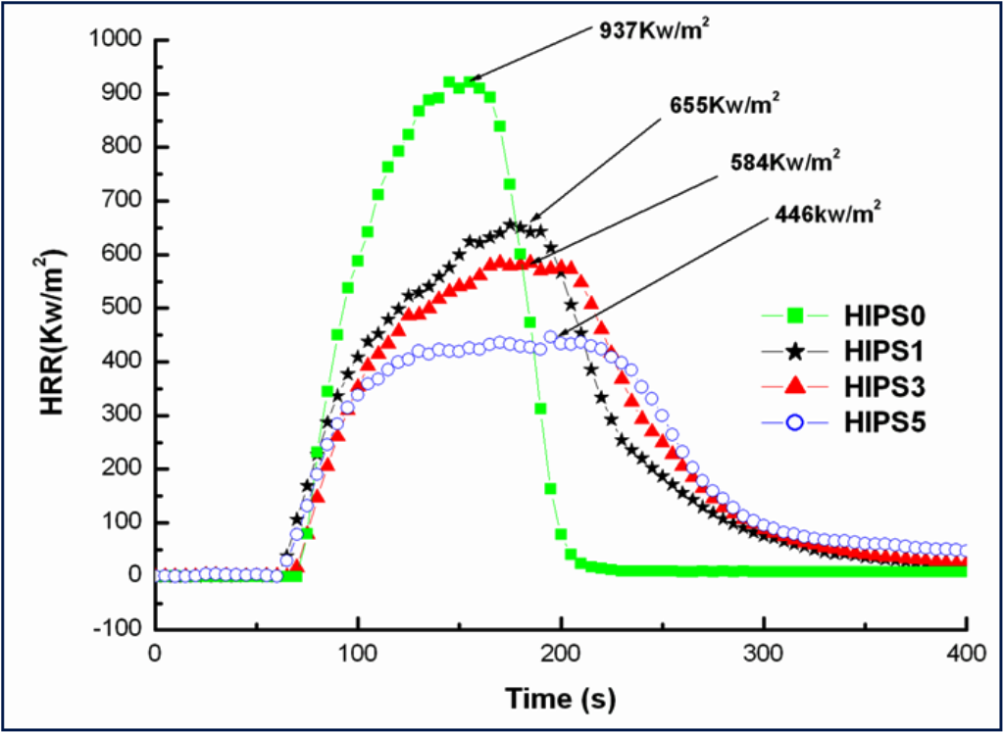
Figure 1. The HRR curves of HIPS composites with different content of Fe-OMT.

Table 1. The pHRR data for the HIPS composites obtained from cone calorimeter.
Samples | pHRR (kW/m²)
HIPS0 | 937
HIPS1 | 655
HIPS3 | 584
HIPS5 | 446

Equation citations in the text may be abbreviated to Eq. with the relevant number, e.g. “Eq.1” or “Eq.1-3” for a group (numbered sequentially at the right-hand side in parentheses (Times New Roman 12 pt)). Equations should be typewritten accompanied by the meaning of all symbols. Equations themselves will be preceded and followed by a blank single line.

Conclusion

References
References should be numbered consecutively throughout the text and should be collected together in a reference list at the end of the text as illustrated below. Numerals for references are given in square brackets [ ]; each number should correspond to a single reference, i.e. multiple references are not acceptable. In the reference list, journals [1], patents [2] and books [3] should be cited in accordance with the following examples:

[1] Y. Zhang, Y. Hu, L. Song, J. Wu, S.L. Fang, Polym. Adv.Technol. 2008, 19, 960-966.
[2] J. H. Gardner, US Patent 3629365, 1971.
[3] G. D. Wignall, In Encyclopedia of Polymer Science and Engineering, 2nd ed.; H. F.Mark, N. M. Bikales, C. C. Overberger, G. Mengens, Eds. Wiley-Interscience: New York, 1999, Vol. 10, pp 112.

Contribution email address: aofsm-symposium@outlook.com

